Tercera actividad flutter: Formulario y validaciones
Código:
import 'package:flutter/material.dart';

void main() {
runApp(const MyApp());
}

class MyApp extends StatelessWidget {
const MyApp({super.key});

@override
Widget build(BuildContext context) {
return MaterialApp(
title: 'Formulario de Registro',
theme: ThemeData(
primarySwatch: Colors.blue,
fontFamily: 'Raleway',
colorScheme: const ColorScheme.light(),
),
debugShowCheckedModeBanner: false,
home: const RegisterPage(title: 'Formulario de Registro'),
);
}
}

enum SinginCharacter { femenino, masculino }
enum CivilState { soltero, casado }

class RegisterPage extends StatefulWidget {
const RegisterPage({super.key, required this.title});
final String title;

@override
State<RegisterPage> createState() => _RegisterPageState();
}

class _RegisterPageState extends State<RegisterPage> {
SinginCharacter? _sex = SinginCharacter.femenino;
CivilState? _civilState = CivilState.soltero;
String _nombre = '';
String _password = '';
final _formKey = GlobalKey<FormState>();

@override
Widget build(BuildContext context) {
return Scaffold(
backgroundColor: const Color.fromARGB(255, 156, 213, 162),
body: SingleChildScrollView(
child: Container(
margin: const EdgeInsets.only(top: 40, left: 30, right: 30),
child: Column(
crossAxisAlignment: CrossAxisAlignment.start,
children: <Widget>[
Container(
margin: const EdgeInsets.only(top: 20),
child: const Text(
'Registrarse',
style: TextStyle(
fontWeight: FontWeight.bold,
fontSize: 32,
color: Color.fromARGB(255, 32, 71, 34),
),
),
),
const Padding(
padding: EdgeInsets.symmetric(vertical: 10),
child: Text(
'¡Ya puedes registrarte, bienvenido!',
style: TextStyle(
color: Color(0xFF666666),
),
),
),
Form(
key: _formKey,
child: Column(
children: <Widget>[
Padding(
padding: const EdgeInsets.only(top: 20),
child: TextFormField(
decoration: InputDecoration(
hintText: 'Nombre',
hintStyle: const TextStyle(fontWeight: FontWeight.w600),
fillColor: Colors.white,
focusedBorder: OutlineInputBorder(
borderSide: const BorderSide(
color: Color(0xFF2E7D32),
width: 2,
),
borderRadius: BorderRadius.circular(8),
),
enabledBorder: OutlineInputBorder(
borderSide: const BorderSide(
color: Color(0xFFCCCCCC),
width: 1,
),
borderRadius: BorderRadius.circular(8),
),
filled: true,
contentPadding: const EdgeInsets.symmetric(horizontal: 16, vertical: 12),
),
validator: (value) {
if (value == null || value.isEmpty) {
return 'Por favor ingrese su nombre';
} else if (value.length < 6) {
return 'El nombre debe tener al menos 6 caracteres';
} else if (value.length > 20) {
return 'El nombre no puede tener más de 20 caracteres';
}
return null;
},
onSaved: (value) {
setState(() {
_nombre = value.toString();
});
},
),
),
Padding(
padding: const EdgeInsets.only(top: 15),
child: TextFormField(
decoration: InputDecoration(
hintText: 'Apellidos',
hintStyle: const TextStyle(fontWeight: FontWeight.w600),
fillColor: Colors.white,
focusedBorder: OutlineInputBorder(
borderSide: const BorderSide(
color: Color(0xFF2E7D32),
width: 2,
),
borderRadius: BorderRadius.circular(8),
),
enabledBorder: OutlineInputBorder(
borderSide: const BorderSide(
color: Color(0xFFCCCCCC),
width: 1,
),
borderRadius: BorderRadius.circular(8),
),
filled: true,
contentPadding: const EdgeInsets.symmetric(horizontal: 16, vertical: 12),
),
validator: (value) {
if (value == null || value.isEmpty) {
return 'Por favor ingrese su apellido';
} else if (value.length < 5) {
return 'El apellido debe tener al menos 5 caracteres';
} else if (value.length > 20) {
return 'El apellido no puede tener más de 20 caracteres';
}
return null;
},
),
),
Padding(
padding: const EdgeInsets.only(top: 15),
child: Row(
children: <Widget>[
Row(
mainAxisAlignment: MainAxisAlignment.spaceBetween,
children: [
Radio<SinginCharacter>(
value: SinginCharacter.femenino,
groupValue: _sex,
activeColor: const Color(0xFF2E7D32),
onChanged: (SinginCharacter? value) {
setState(() {
_sex = value;
});
},
),
const Text('Femenino')
],
),
Row(
children: [
Radio<SinginCharacter>(
value: SinginCharacter.masculino,
groupValue: _sex,
activeColor: const Color(0xFF2E7D32),
onChanged: (SinginCharacter? value) {
setState(() {
_sex = value;
});
},
),
const Text('Masculino')
],
),
],
),
),
Padding(
padding: const EdgeInsets.only(top: 15),
child: Row(
children: <Widget>[
Row(
mainAxisAlignment: MainAxisAlignment.spaceBetween,
children: [
Radio<CivilState>(
value: CivilState.soltero,
groupValue: _civilState,
activeColor: const Color(0xFF2E7D32),
onChanged: (CivilState? value) {
setState(() {
_civilState = value;
});
},
),
const Text('Soltero')
],
),
Row(
children: [
Radio<CivilState>(
value: CivilState.casado,
groupValue: _civilState,
activeColor: const Color(0xFF2E7D32),
onChanged: (CivilState? value) {
setState(() {
_civilState = value;
});
},
),
const Text('Casado')
],
),
],
),
),
Padding(
padding: const EdgeInsets.only(top: 15),
child: TextFormField(
decoration: InputDecoration(
hintText: 'Correo electrónico',
hintStyle: const TextStyle(fontWeight: FontWeight.w600),
fillColor: Colors.white,
focusedBorder: OutlineInputBorder(
borderSide: const BorderSide(
color: Color(0xFF2E7D32),
width: 2,
),
borderRadius: BorderRadius.circular(8),
),
enabledBorder: OutlineInputBorder(
borderSide: const BorderSide(
color: Color(0xFFCCCCCC),
width: 1,
),
borderRadius: BorderRadius.circular(8),
),
filled: true,
contentPadding: const EdgeInsets.symmetric(horizontal: 16, vertical: 12),
),
validator: (value) {
if (value == null || value.isEmpty) {
return "El correo es necesario";
} else if (!value.contains('@')) {
return "El correo debe contener el carácter @";
}
return null;
},
),
),
Padding(
padding: const EdgeInsets.only(top: 15),
child: TextFormField(
obscureText: true,
onChanged: (value) {
setState(() {
_password = value;
});
},
decoration: InputDecoration(
hintText: 'Contraseña',
hintStyle: const TextStyle(fontWeight: FontWeight.w600),
fillColor: Colors.white,
focusedBorder: OutlineInputBorder(
borderSide: const BorderSide(
color: Color(0xFF2E7D32),
width: 2,
),
borderRadius: BorderRadius.circular(8),
),
enabledBorder: OutlineInputBorder(
borderSide: const BorderSide(
color: Color(0xFFCCCCCC),
width: 1,
),
borderRadius: BorderRadius.circular(8),
),
filled: true,
contentPadding: const EdgeInsets.symmetric(horizontal: 16, vertical: 12),
),
validator: (value) {
if (value == null || value.isEmpty) {
return "La contraseña es necesaria";
} else if (value.length < 10) {
return "La contraseña debe tener al menos 10 caracteres";
} else if (value.length > 20) {
return "La contraseña no puede tener más de 20 caracteres";
}
return null;
},
),
),
Padding(
padding: const EdgeInsets.only(top: 15),
child: TextFormField(
obscureText: true,
decoration: InputDecoration(
hintText: 'Confirmar contraseña',
hintStyle: const TextStyle(fontWeight: FontWeight.w600),
fillColor: Colors.white,
focusedBorder: OutlineInputBorder(
borderSide: const BorderSide(
color: Color(0xFF2E7D32),
width: 2,
),
borderRadius: BorderRadius.circular(8),
),
enabledBorder: OutlineInputBorder(
borderSide: const BorderSide(
color: Color(0xFFCCCCCC),
width: 1,
),
borderRadius: BorderRadius.circular(8),
),
filled: true,
contentPadding: const EdgeInsets.symmetric(horizontal: 16, vertical: 12),
),
validator: (value) {
if (value == null || value.isEmpty) {
return 'Por favor confirme su contraseña';
} else if (value != _password) {
return 'Las contraseñas no coinciden';
}
return null;
},
),
),
Padding(
padding: const EdgeInsets.symmetric(vertical: 30),
child: SizedBox(
width: double.infinity,
height: 50,
child: ElevatedButton(
onPressed: () {
if (_formKey.currentState!.validate()) {
ScaffoldMessenger.of(context).showSnackBar(
SnackBar(
content: Row(
mainAxisAlignment: MainAxisAlignment.start,
children: const <Widget>[
Icon(
Icons.check_circle,
color: Colors.white,
),
SizedBox(width: 8),
Text(
"Usuario registrado correctamente",
style: TextStyle(color: Colors.white),
)
],
),
duration: const Duration(milliseconds: 2000),
width: 300,
padding: const EdgeInsets.symmetric(
horizontal: 16.0,
vertical: 12,
),
behavior: SnackBarBehavior.floating,
shape: RoundedRectangleBorder(
borderRadius: BorderRadius.circular(8.0),
),
backgroundColor: Color(0xFF2E7D32),
),
);
}
},
style: ElevatedButton.styleFrom(
backgroundColor: const Color(0xFF2E7D32),
foregroundColor: Colors.white,
shape: RoundedRectangleBorder(
borderRadius: BorderRadius.circular(8),
),
elevation: 2,
),
child: const Text(
'Registrarse',
style: TextStyle(
fontSize: 16,
fontWeight: FontWeight.bold,
),
),
),
),
),
],
),
)
],
),
),
),
);
}
}

Capturas:
Campos con errores (diligenciados erróneamente):
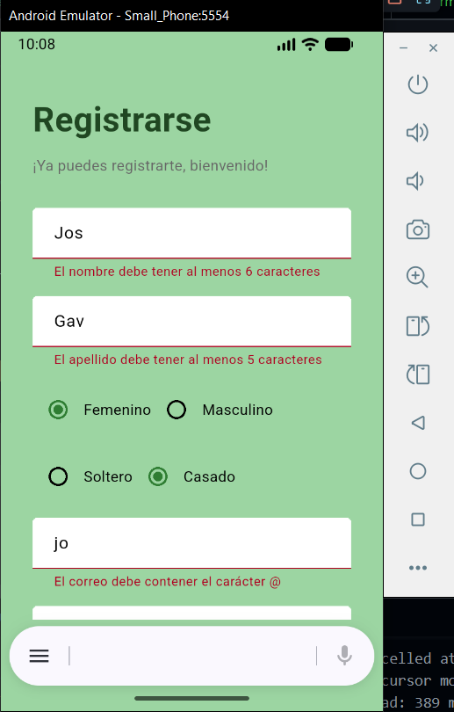

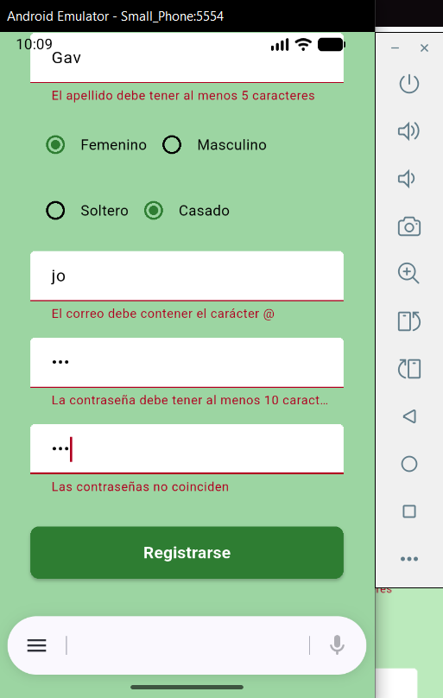

Campos sin errores:
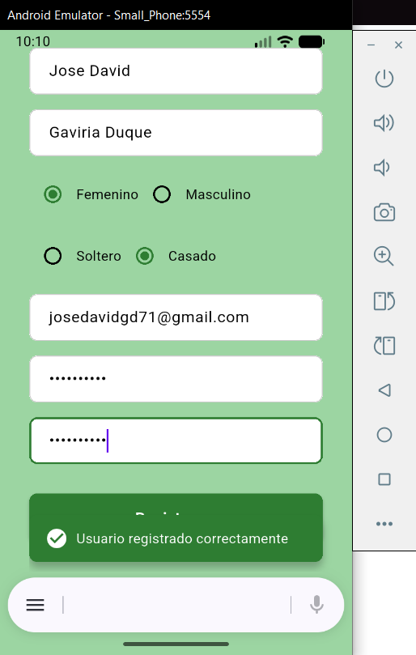

Repositorio GitHub: https://github.com/JoseGd12/Flutter-5to-trimestre.git

